Equations of equilibrium of concurrent force system in a plane
We have seen that the resultant of a system of concurrent coplanar forces can be found out using the equation, $R=\sqrt{{ΣF_{x}}^{2}+{ΣF_{y}}^{2}}$.
If the force system is in equilibrium, then the resultant of the force system should be zero. This is possible only if $ΣF_{x}=0$ and $ΣF_{y}=0$. Hence, the equations of equilibrium for concurrent forces in a plane are,
$ΣF_{x}=0$ and $ΣF_{y}=0$
Example 1  Three balls of radius $r=10 cm$ and weight $W=100 N$ each resting on a trough as shown. Determine the support reactions at $A, B, C$, and $D$. |  | $$50cm$$  $$B$$  $$A$$  $$D$$  $$C$$
Consider the freebody diagram$θ$ of the whole system  $$ΣF_{x}=0 ≫≫ R_{3}-R_{4}=0 ≫≫ R_{3}= R_{4}$$  $$ΣF_{y}=0 ≫≫ R_{1}+R_{2}-100-100-100=0 ≫ R_{1}+R_{2}=300$$  From the geometry,  $$10+20\cos{θ}+20\cos{θ}+10=50 ≫\cos{θ}=\frac{3}{4} ≫{θ}=41.4°$$ | $W$=100 N  $$W$$  $$W$$  $$R_{31}$$  $$R_{1}$$  $$R_{2}$$  $$R_{41}$$  $$θ$$  $$θ$$
Consider the free-body diagram of ball 1  $$ΣF_{x}=0 ≫≫R\cos{41.4°}-R^{'}\cos{41.4°}=0≫≫R=R'$$  $$ΣF_{y}=0 ≫≫R\sin{θ}+R^{'}\sin{θ}=100≫≫R=\frac{100}{2×sin{41.4}}=75.6 N$$  Equilibrium of ball 2  $$ΣF_{x}=0≫≫ R_{3}-R\cos{41.4°}=0 ≫R_{3}=56.7 N$$  $$ΣF_{y}=0 ≫≫R_{1}-R\sin{41.4°}-100=0≫≫ R_{1}=150 N$$  $$R_{2}=150 N ≪≫ R_{4}=56.7 N$$ | $$3$$  $$2$$  $$1$$  $$θ$$  $$θ$$  $$W$$  $$W$$  $$W$$  $$R_{3}$$  $$R_{1}$$  $$R_{2}$$  $$R_{41}$$  $$θ$$  $$θ$$  $$R'$$  $$R'$$  $$R$$  $$R$$
Example 2  Three balls of radius $r=10 cm$ and weight $W=100 N$ each resting on a smooth floor. Determine the support reactions at $A$and $B$ and the tension if a string keeps the balls from moving. | $$D$$  $$A$$  $W$=100 N  $$W$$  $$W$$  $$R_{1}$$  $$R_{2}$$  $$C$$  $$B$$  $$50cm$$
Consider the freebody diagram$θ$ of the whole system  $$ΣF_{y}=0 ≫≫ R_{1}+R_{2}-100-100-100=0 ≫ R_{1}+R_{2}=300$$  From the geometry,  $$10+20\cos{θ}+20\cos{θ}+10=50 ≫\cos{θ}=\frac{3}{4} ≫{θ}=41.4°$$ | $$θ$$  $$θ$$
Consider the free-body diagram of ball 1  $$ΣF_{x}=0 ≫≫R\cos{41.4°}-R^{'}\cos{41.4°}=0≫≫R=R'$$  $$ΣF_{y}=0 ≫≫R\sin{θ}+R^{'}\sin{θ}=100≫≫R=\frac{100}{2×sin{41.4}}=75.6 N$$  Equilibrium of ball 2  $$ΣF_{x}=0≫≫ T-R\cos{41.4°}=0 ≫T=56.7 N$$  $$ΣF_{y}=0 ≫≫R_{1}-R\sin{41.4°}-100=0≫≫ R_{1}=150 N$$  $$R_{2}=150 N$$ | $$W$$  $$W$$  $$W$$  $$T$$  $$R_{1}$$  $$R_{2}$$  $$T$$  $$3$$  $$2$$  $$1$$  $$θ$$  $$θ$$  $$θ$$  $$θ$$  $$R'$$  $$R'$$  $$R$$  $$R$$

Example 3  Determine the weight of the cylinder A which will keep the system in equilibrium. Neglect the friction in the pulley at B. | 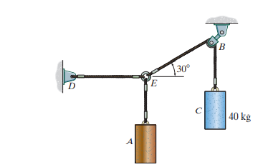
Free body diagram of the cylinder C  $$ΣF_{y}=0 ≫≫T-W=0 ≫T=392 N$$  Since, the friction in the pulley B is neglected, the tension in the string $CBE$ will be the same |  | $$W=392N$$  $$T$$
Free-body diagram of $E$  $$ΣF_{x}=0 ≫≫T\cos{30}-T^{'}=0 ≫T^{'}=339.5 N$$  $ΣF_{y}=0 ≫≫T\sin{30-W'=0}$ $≫W^{'}=196 N$ | $$T=392 N$$  $$30°$$  $$T'$$  $$W'$$

Exercise 1.  Two smooth pipes, each having a mass of $300 kg$, are supported by the forked tines of a tractor as shown. Determine the reactions at the supports $A, B,$ and$C$. | 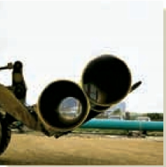 | 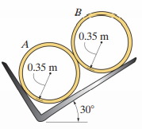  $$C$$  $$B$$  $$A$$
Exercise 2.  Determine the tension in the cables $AB$ and $BC$ if the cylinder weighs $600 N$. | 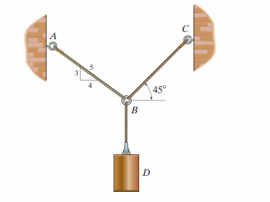
Exercise 3.  Determine the tension in the cables $AB,$ $BC$ and $AD.$ | 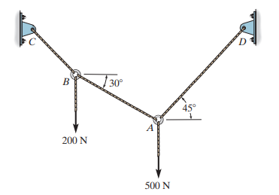
Exercise 4  If each cable can withstand a maximum load of 500 N, what is the maximum possible weight of the suspended cylinder? | 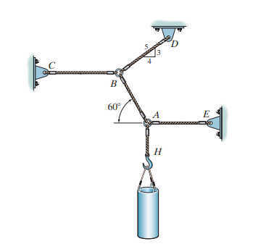

Reference
- Engineering Mechanics: Timoshenko and Young, McGraw Hill
- Mechanics for Engineers: Beer & Johnston, McGraw Hill
- Engineering Mechanics: Merriam & Kraig, Wiley
- Engineering Mechanics: Hibbeler, Pearson

